15-112 Term Project Competitive Analysis

Shaojie Bai

One of the games on the Internet close to the **Cellular War** that I am making is the "Cloud War"--- though it is a bit easier. The game "Cloud War" can be found at the website below:

<http://www.kanogames.com/play/game/cloud-wars>

And here is one of the screenshots I take of the game:

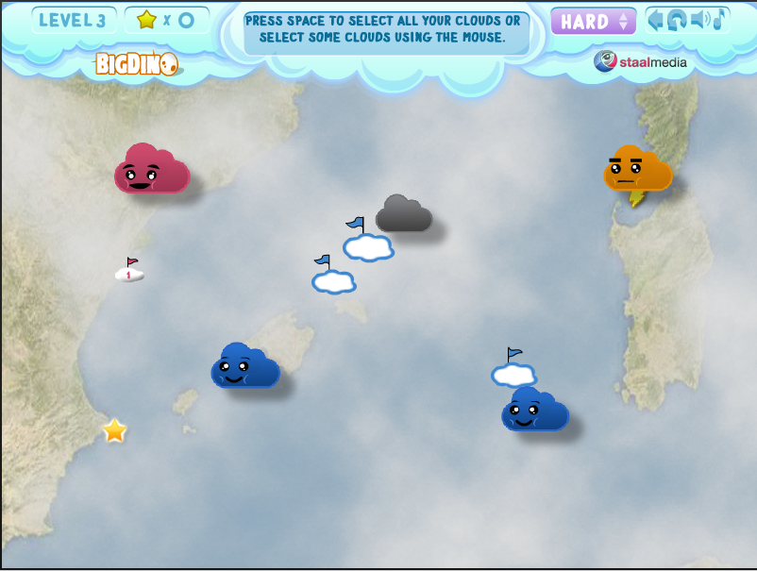

Figure 1. Cloud War

There are a few very good features that will be quite useful to my game design:

(1) When you drag a mouse from one cloud to the other, a blue line "travels" with the arrow such that it is easier for users to see what is going to be the target.

(2) As a cloud becomes stronger, its size gets larger. I am considering something similar, but using color instead.

(3) It has a good Artificial Intelligence (AI) in that the enemy cloud can attack the neutral / (my) friendly cloud with clever decisions.

However, the types of cloud are too simple, and the interface is not as satisfactory as I expected. These may be two aspects I want to seek improvements on.